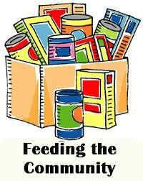
District 28 Food Drive

at the
2015 Fall Conference - November 6th & 7th
Bring Your Non-Perishable Food Items
Canned Goods, Pasta, Side Dishes, Cereals, Breakfast Bars, Canned Meat/Fish, Peanut Butter, Jelly, Soups & Baby Formula

ALL FOOD COLLECTED AT THE CONFERENCE WILL BE DONATED TO THE SEAGATE FOOD BANK (LOCATED IN TOLEDO OHIO) ON BEHALF OF DISTRICT 28
The Seagate Food bank is an independent non-profit agency helping to serve hungry individuals, seniors, and Veterans in eight counties throughout Northwest Ohio.
“If you can't feed a hundred people, then feed just one.” Mother Teresa
Toastmasters Making a Difference, One CAN at a TIme!

